**VR Project 4 – Puzzler**

This project is built based on the Udacity’s instructions, with the help of my friends on user testing inputs.

**Game Logic**

Once player starts the game, he/she will be led into a dungeon, with 5 magic crystal balls in front.

The sorcerer has encoded a sequence that the 5 crystal balls will be lit on in order.

To escape the dungeon, the player must remember the sequence and reproduce the order by clicking crystal balls.

The sorcerer has some mercy that the player can have unlimited tries, and will be shown the sequence again every time he/she fails.

**Statement of Purpose**

This project is to exercise the design process and user testing.

**Persona**

Name: Xiaoxi Guo

Age: 28

VR Experience: None

Quote: “I would love to have a taste on VR!”

About this person: Xiaoxi is a business major student, and she likes to get familiar with VR applications, to grow a sense in the technical field, as she plans to join tech companies as product manager.

**User Tests**

**Test 1**

Xiaoxi thought the balls should have highlight when reticle hover over and a sound should play when player clicks the crystal balls.

**Test 2**

Xiaoxi felt the light is so dim, so I added more lights to make 5 lights on the wall, and also adjusted the light from above the crystal balls.

**Design Sketch**

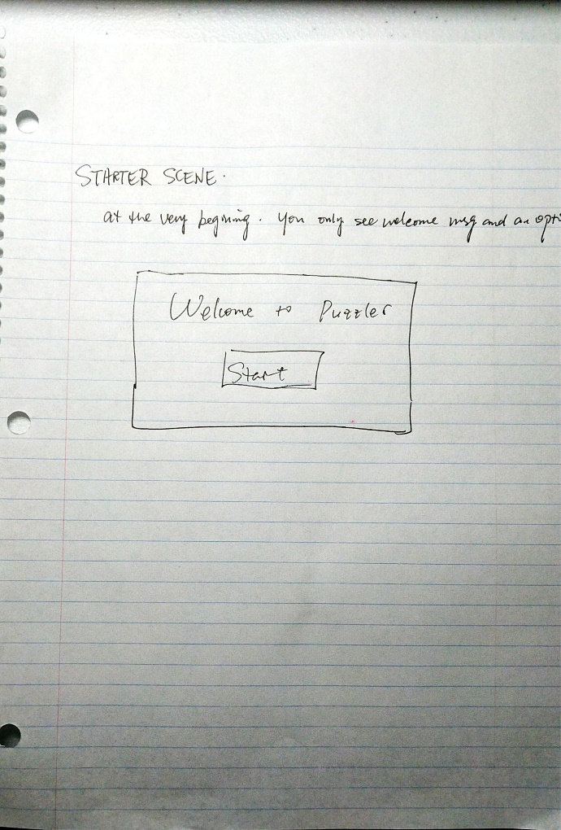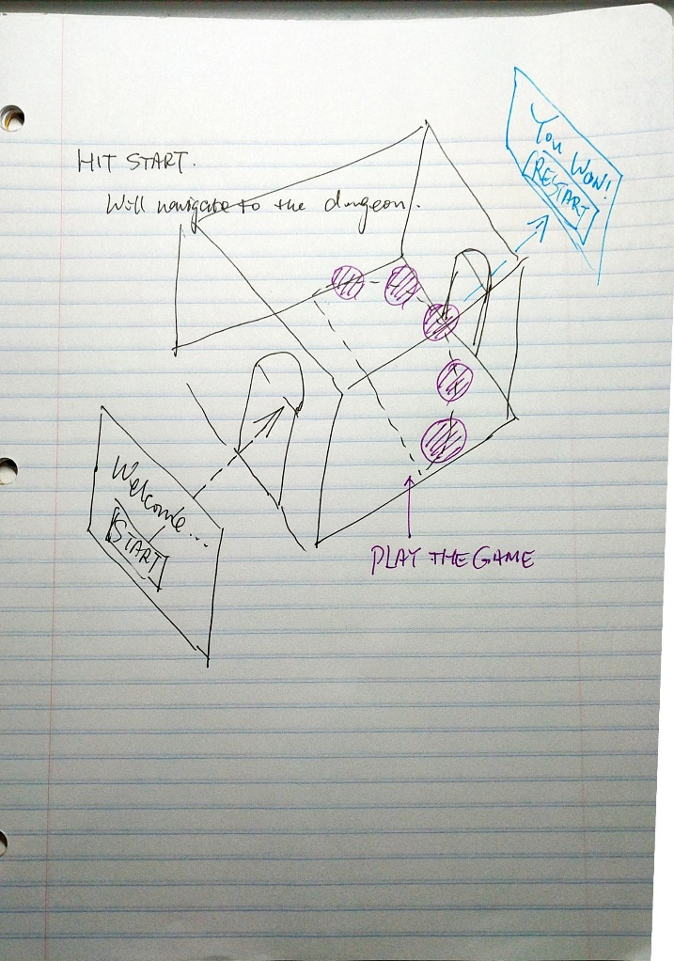

**Video of Game Play**

